

**PAF-Karachi Institute of Economics and Technology**

**College of Computing and Information Sciences - North Campus**

**Internet & Intranet Architecture**

**Assignment – 1**

**NAME: Syed Muzzamil Waseem**

**SID: 11067**

**CID: 109138**

**Instructions** (**READ AND FOLLOW INSTRUCTIONS CAREFULLY**):

* **In case of CHEATING, COPIED material or any unfair means would result in ZERO marks.**
* Mention your name and ID above and write solution in this file and then submit in word or PDF format.
* Late submission will result in mark deduction

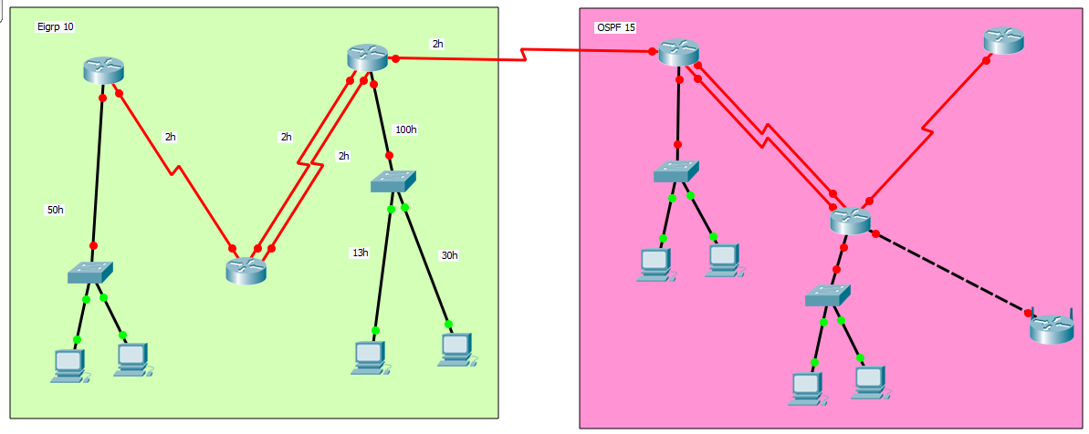

**Instructions (for Topology Configuration)**

* Change all router hostname with your name
* Use major network which is assigned to you only
* Configure Eigrp on left side.
* Configure the Eigrp part using VLSM.
* Configure DHCP on Wireless Router
* While configuring Eigrp configure summarize route.
* Configure floating routes where necessary.
* All routers should communicate with each other.
* All end devices should communicate within their respective areas
* Submit screenshot of topology with network labels
* Submit screenshots of routing table of all routers
* Submit screenshot of DHCP

**If anyone failed to follow any instruction I will deduct 1 marks for each instruction.**

**[Solution]**

**TOPOLOGY WITH NETWORK LABELS:**

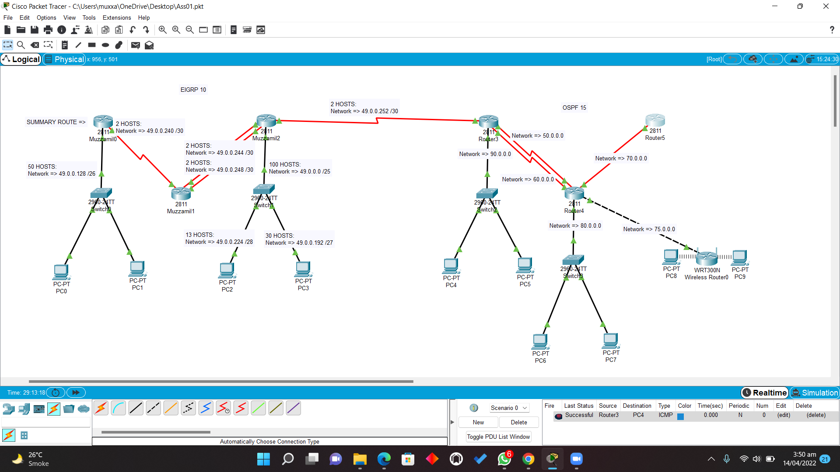

**EIGRP CONFIGURATION:**

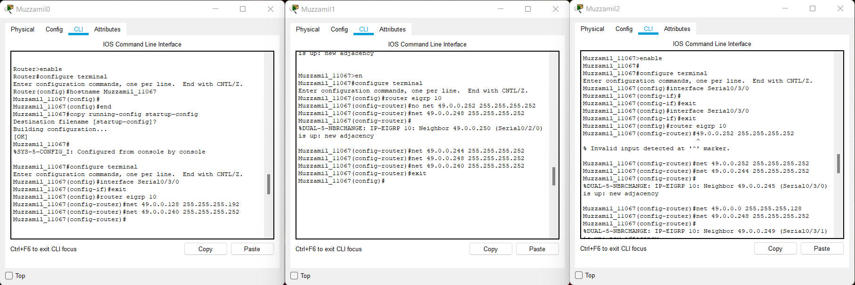

**SUMMARY ROUTE:**

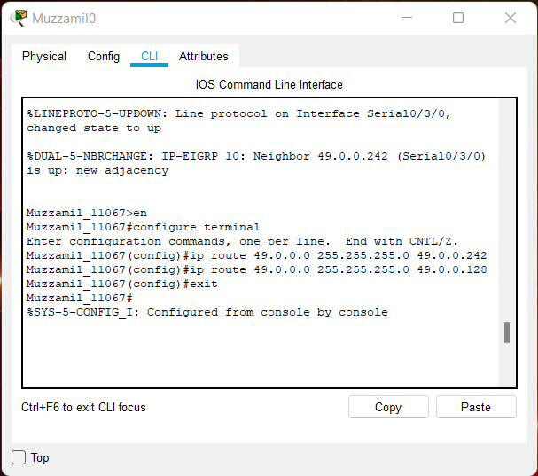

**FLOATING ROUTES:**

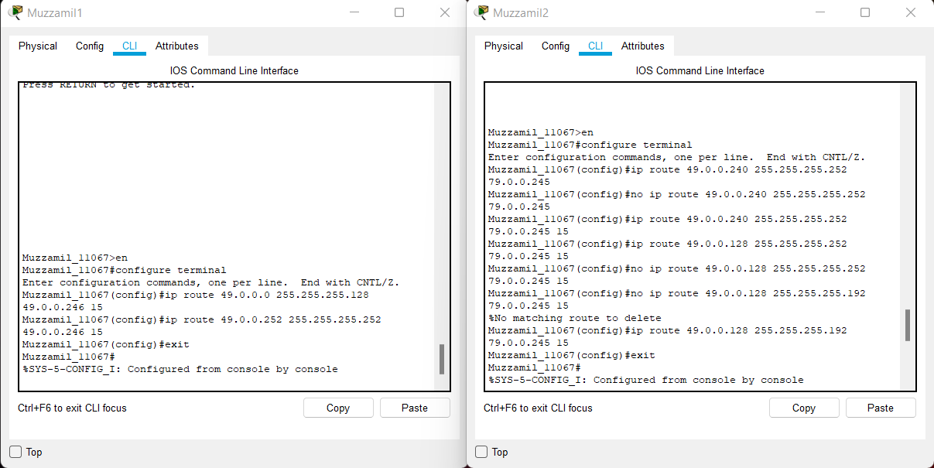

**TESTING COMMUNICATION WITH ROUTERS AND END DEVICES:**

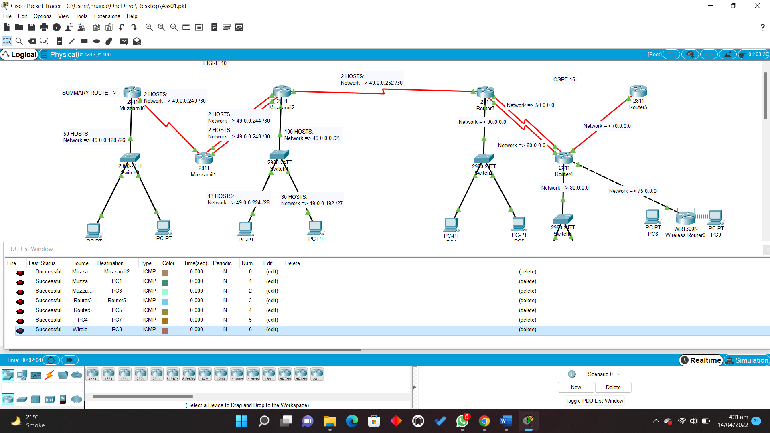

**ROUTING TABLES:**

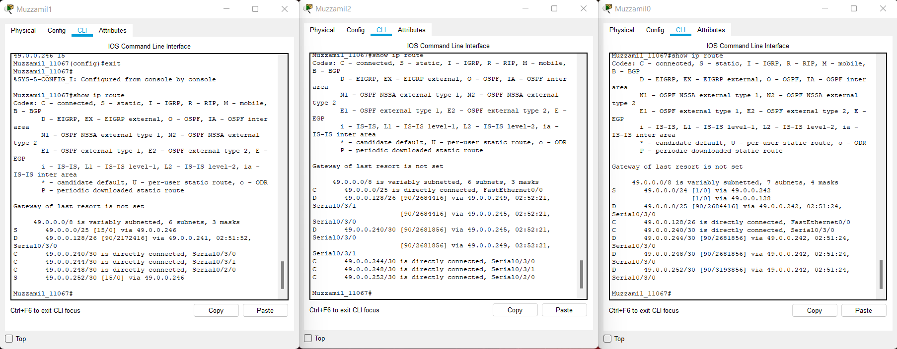

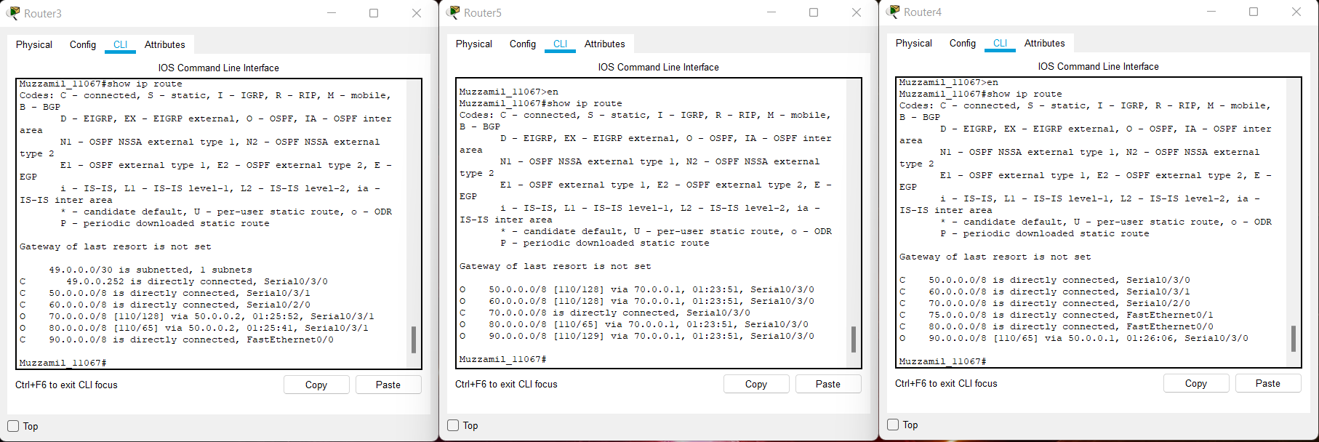

**OSPF CONFIGURATION:**

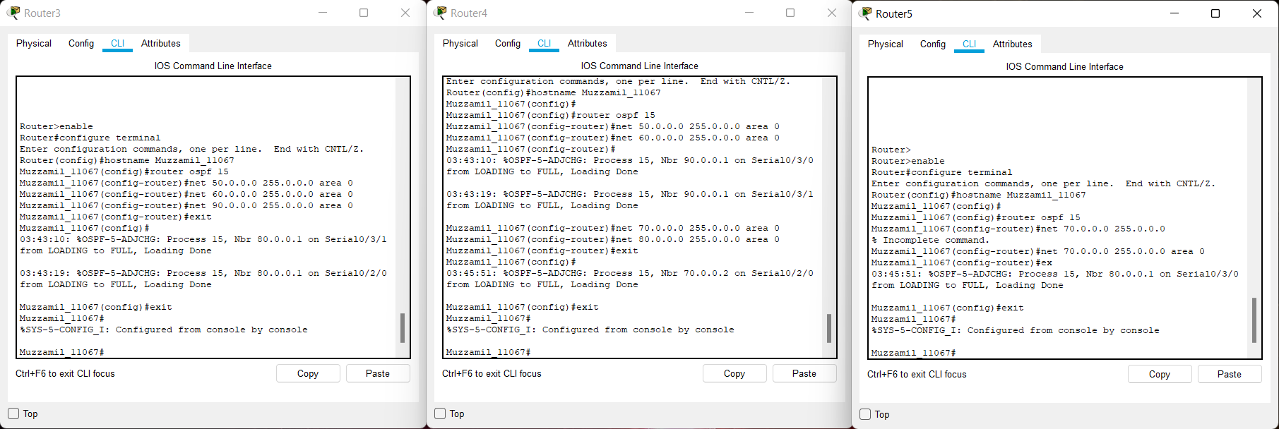

**DHCP CONFIGURATION AND CHECK ITS CONNECTIVITY WITH END DEVICES:**

